Daniel Koirala
CSIII
Lab 1 Report
08/25/2025

Output:

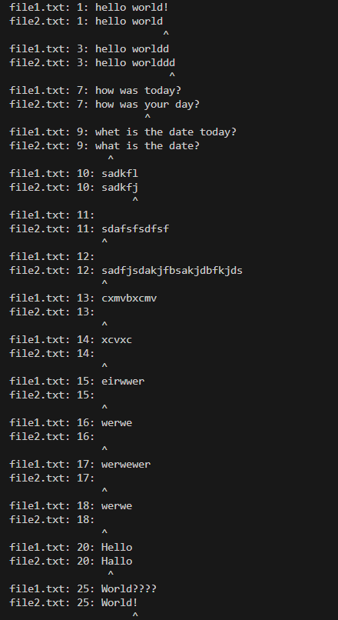

I grabbed the test files file1.txt and file2.txt from Nesterenko’s website:
http://antares.cs.kent.edu/~mikhail/classes/cs3/Labs/Lab1/

AI Usage:

At one point I had an issue with my output looking like this:

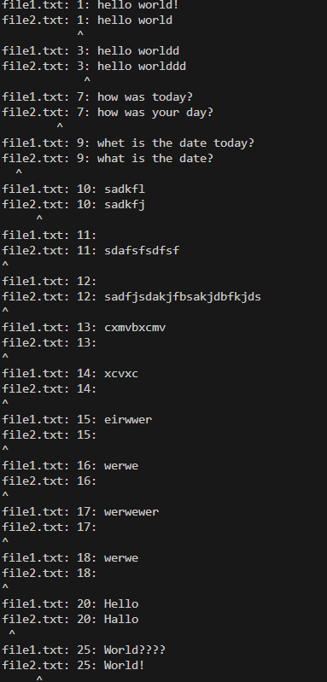

I thought it was an issue with the differing character logic but that was not the case. ChatGPT led me on a wild goose chase to fix a logic bug that didn’t exist. I realized it was just a visual output format bug and instead added a prefix that appended the caret after “:”

That fixed the issue I had, so I ended up wasting time with ChatGPT.

